 | INCIDENT  REPORT | NORTHLAND FC USE ONLY  I R #:  Report  Name:  Date  Received:

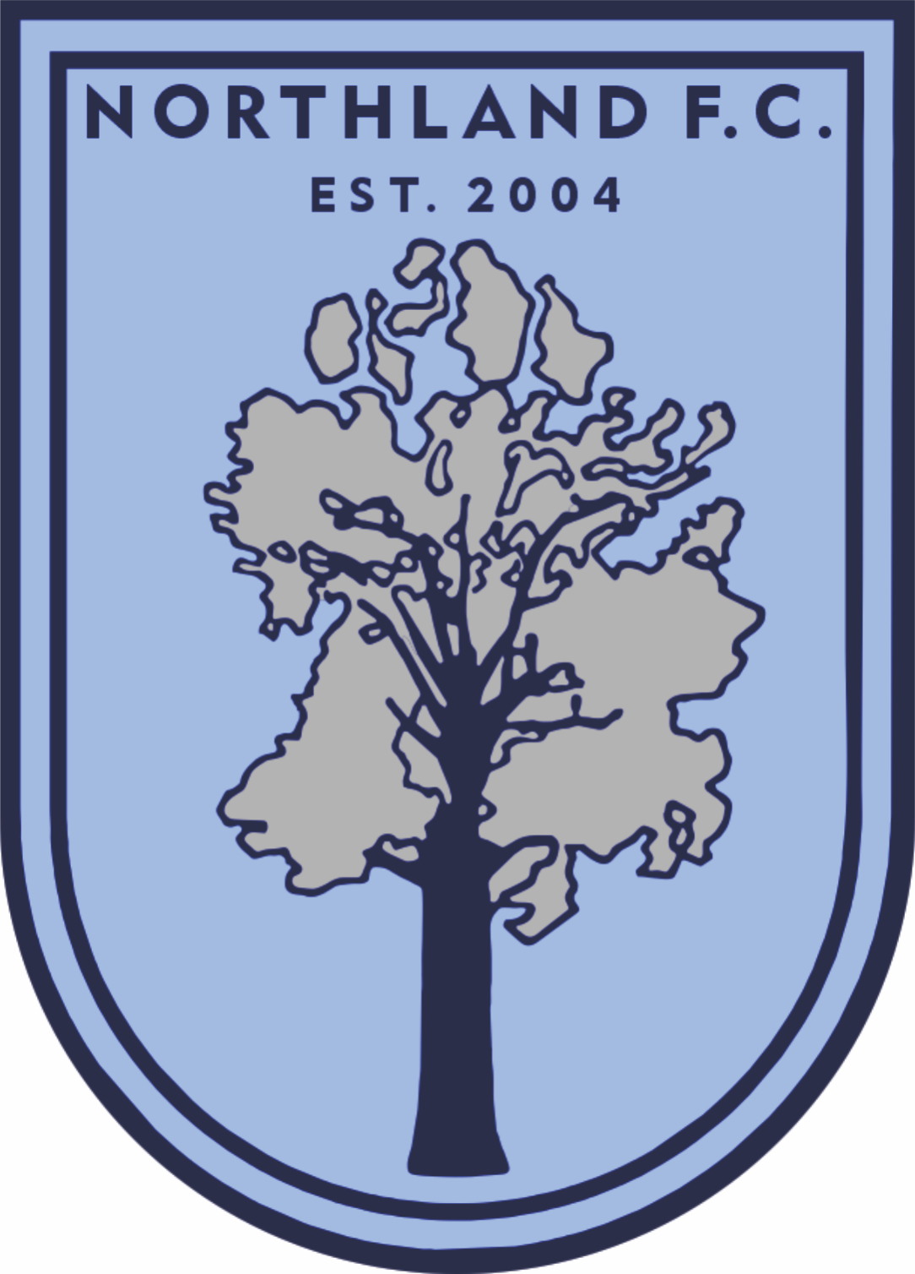

REPORTED BY Date:

Name: ____ Club:
(Print Name)

Email address: Mobile Number: _____

GAME DETAILS (IF APPLICABLE)

V

Competition: Grade:

Ground: Date: Kick off:

INCIDENT DETAILS

The following incident occurred:

at a game at training on the road other. Time of the incident

If the names of the person(s) involved are known, please provide below, and indicate the status of the person, e.g. a player, coach, manager, club official, spectator or other (please specify):

NAME | POSITION | CLUB

This form is to be used to report a significant incident that may also, if relevant, be accompanied with an NRF Incident Report Form.

The form must be submitted to the General Manager at the earliest possible opportunity.
The completed form must be emailed to: manager@northlandfootball.net OR
Posted or delivered to: The General Manager, Northland FC, 39 Park Avenue, Kensington, Whangarei 0112.

Incident description section overleaf

DESCRIPTION OF THE INCIDENT / COMPLAINT / PROTEST
(Describe fully events leading up to and about the Incident or Complaint)

ENDORSEMENT

Name: ____
(Please Print Name in Capitals)

Email address: Mobile Number: _____

